Downingtown West Little League (DWLL) 2026 Safety Manual

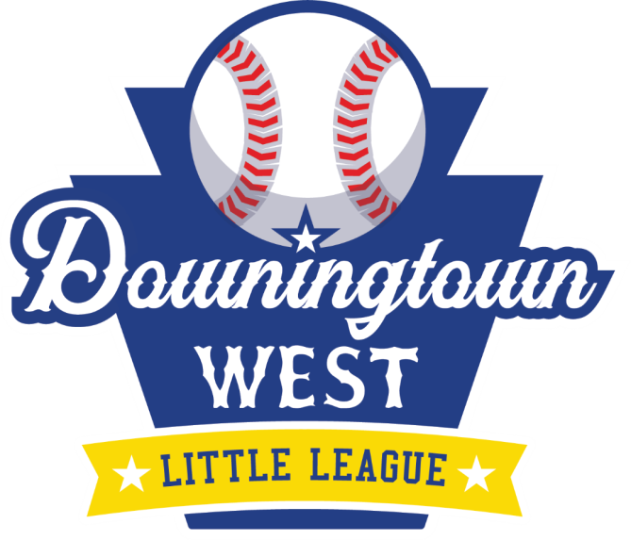

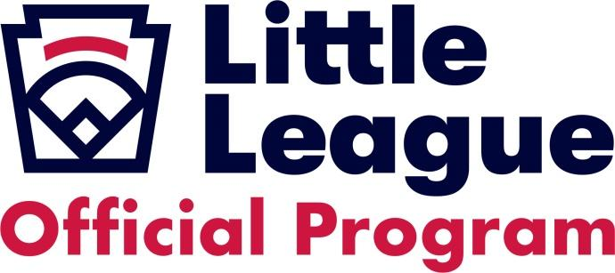
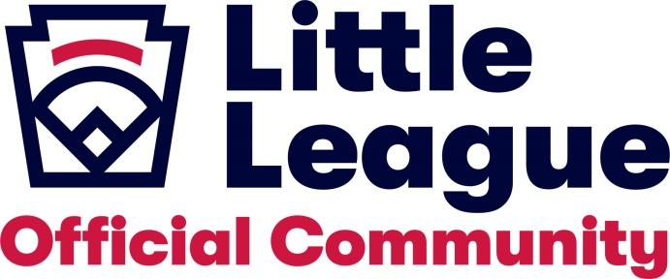
Contents
1 DWLL Mission Statement 4
2 Introduction 4
3 DWLL 2026 Safety Officer 4
4 Safety Manual Distribution 4
5 Important Phone Numbers 5
6 Child abuse 5
7 Incident Reporting and Action Plan: 5
7.1 WHAT to Report: 5
7.2 WHEN to Report 5
7.3 HOW to Make the Report 6
7.4 Accident Report Follow-up 6
8 Roles and Responsibilities 6
8.1 Safety Officer Responsibilities 6
8.2 League Responsibilities 6
8.2.1 Field Maintenance 8
8.2.2 Coaching Coordination 8
8.2.3 Concession Stand 9
8.2.4 Equipment 9
8.2.5 Inclement Weather 10
8.3 Coach Responsibilities 10
8.4 Parent Responsibilities 11
8.5 Code of Conduct 11
9 Volunteer Eligibility 12
9.1 Complete volunteer registration form 12
9.2 Abuse Awareness Training 12
9.3 Background Checks 12
10 Injury Prevention 13
10.1 Athletic Conditioning 13
11 Guidelines Regarding Communicable Respiratory Infections (e.g., COVID-19) 13
11.1 DWLL Respiratory Infection Guidelines 13
11.2 Relevant Guidance 13
12 Field Locations 14
13 2026 DWLL Board of Directors 14
14 Medical Release Form 14
15 Incident/Injury Tracking Report Form 17
16 Little League Volunteer Application Form 18

DWLL Mission Statement
It is the intent of the Downingtown West Little League, its Board of Directors, Managers, Coaches, and Volunteers to provide the youth of Downingtown Borough and West Bradford Township with an opportunity to learn, play, and enjoy the great game of baseball and softball in a safe, friendly environment with an emphasis on teamwork, sportsmanship, and fair play.

Introduction
Downingtown West Little League has prepared this manual to help raise awareness of some key safety information and guidelines.

DWLL 2026 Safety Officer
The 2026 DWLL Safety Officer is A.J. Ober, and he has been registered as such with Little League International. He can be reached via the following means:
- Phone: 215-779-3433
- Official email: safety@dwestll.org

Safety Manual Distribution
The DWLL Board commits to making the DWLL 2026 Safety Manual accessible to coaches, managers, board members, and any other volunteer in the league.
The Safety Manual link on the Downingtown West Little League website (www.dwestll.org) will be referenced to all board members, coaches, and team managers at the 2026 Safety Clinic. A copy of the Safety Manual will also be available in the Safety binder located inside the Snack Shacks located at both Beacon Hill fields, as well as Manor Avenue fields. The Downingtown West Little League 2026 Safety Manual will be submitted to Little League International in Williamsport, PA by April 1st, 2026.
The safety manuals in the snack shacks will also have envelopes for any suggestions for improvement.

Important Phone Numbers
Following are phone numbers for local emergency services. Contact information for board members (including the Safety Officer) are provided in Section 13: 2026 DWLL Board of Directors.
IN AN EMERGENCY DIAL: | 911
Alert Fire Co. 1 | 610-269-0454
Minquas Fire Co. 2 | 610-269-2797
Downingtown Police | 610-269-0263
State Police – Embreeville Barracks | 610-486-6280
Patient First – Downingtown | 484-593-5160
Chester County Hospital | 610-431-5000
Paoli Hospital – Main Line Health | 484-565-1000

Child abuse
DWLL has a zero-tolerance policy on child abuse. Any incidents, or suspected incidents should be immediately reported to the league Safety Officer, or other board member (note: all board member contact information is listed in section 13 of this document).
At no point are any adult volunteers permitted to interact with minors (players or otherwise) in a 1:1 setting indoors. All interactions should be outdoors in group settings. Indoor training, tryout, or other sessions involving players should always be in groups.

Incident Reporting and Action Plan:

WHAT to Report:
The following items should be reported:
- Any instance of child abuse or suspected child abuse
- Any incident in which player injury occurs
- Any field conditions or practices which appear to be unusually dangerous or risky
- In addition, any incident that causes a player, manager, coach, umpire, volunteer, or spectator to receive medical and/or first aid treatment at Downingtown West Little League locations, and/or activities (e.g., if traveling for “away game”) should be reported.
NOTE: Reporting and tracking near misses is encouraged. This information will be used to develop future measures to ensure safety at our facility.

WHEN to Report
An incident should be reported to the Safety Officer and League President within 48 hours of the incident.

HOW to Make the Report
An ACCIDENT REPORT must be completed. Accident Report forms can be obtained:
- in the Snack bar inside the Safety Binder
- on the Downingtown West Little League web page (http://dwestll.org) or
- in section 15 of this Safety Manual
An accident report should be completed by the relevant coach or volunteer. Once completed, the form must be submitted via email to the Safety Officer and League President. Initial report may be done verbally or by text / email, as long as there is clear follow-up with the formal report.

Accident Report Follow-up
Within 48 hours of receiving the completed accident report, the Safety Officer will contact the injured party to:
- Verify the information reported
- Obtain any additional information
- Check status of the injured party
Any individual requiring medical treatment (Doctor’s Office visit, Urgent Care or Emergency Room Visit, etc) MUST obtain documented medical clearance (ie: Physician note) before returning to game or practice participation.

Roles and Responsibilities

Safety Officer Responsibilities
- Create safety awareness through education and information reporting to provide a safer environment for children and all participants of Downingtown West Little League.
- Develop and implement a plan for increasing safety awareness of activities, equipment, and facilities through education, compliance, and reporting.
  - Education - Facilitate meetings and distribute information among participants - including players, managers, coaches, umpires, league officials, parents, guardians, and other volunteers.
  - Compliance – Promote safety compliance leadership by increasing awareness of safety opportunities that arise from these responsibilities.
  - Reporting – Define a process to assure that incidents are recorded and sent to the league, district, and national offices and follow up information on medical and other data is forwarded to these interested parties as available.

League Responsibilities
- The league will submit league player registration data (or player roster data) and coach and manager through the Little League Data Center.
- Use the Preseason to Review Little League® Rules
- Managers, coaches and umpires should have training in first-aid. It is strongly recommended that they have taken a CPR course. A lecture in First-Aid is to be given at the coach and volunteer orientation prior to the beginning of the season. As a result of any prior training and education, any manager or coach that is a licensed MD, RN, LPN, and/or paramedic/EMT is not required to attend this meeting. Such training will be provided by the league at the preseason mandatory coach’s training meeting (15-March-2026).
- First-aid kits are available to each team manager for teams that travel in the Minor A, Majors, Juniors, Seniors and Softball divisions. These kits should be available in field boxes/sheds and snack bars. Teams planning an away game/practice are advised to bring appropriate first aid kits/ice packs with them.
- Automatic external defibrillators (AED) have been obtained and will be installed or made available at all of the fields. After installation, the locations will be clearly marked and communicated to all coaches. An AED training overview will be provided at the 2026 coach and volunteer orientation meeting.
- All team equipment should be stored within the team dugout, or behind screens, and not within the area defined by the umpires as "in play".
- Only players, managers, coaches, and umpires are permitted on the playing field or in the dugout during games and practice sessions.
- Responsibility for keeping bats and loose equipment off the field of play should be that of a player assigned for this purpose or the team’s manager and coaches.
- During practice and games, all players should be alert and watching the batter on each pitch.
- During warm-up drills players should be spaced so that no one is endangered by wild throws or missed catches.
- All pre-game warm-ups should be performed within the confines of the playing field and not within areas that are frequented by, and thus endanger spectators (i.e., playing catch, pepper, swinging bats, etc.)
- Equipment should be inspected regularly for the condition of the equipment as well as for proper fit.
- Batters must wear Little League approved protective helmets during batting practice and games.
- Enforce rule that coaches and managers are not allowed to catch/warm-up pitchers (Rule 3.09); this includes standing at the backstop during practice as an informal catcher for batting practice.
- Catcher must wear catcher’s helmet (skull caps not permitted), mask, throat guard, long model chest Protector (Majors & below), shin guards and protective cup with athletic supporter at all times (males) for all practices and games. Catcher helmets and chest guards must be NOCSAE compliant and stamped (National Operating Committee on Standards for Athletic Equipment)
  - NO EXCEPTIONS. Managers should encourage all male players to wear protective cups and supporters for practices and games.
- Catcher must wear catcher’s helmet and mask with a throat guard in warming up pitchers.
- Except when a runner is returning to a base, headfirst slides are not permitted.(Majors and below)
- Parents of players who wear glasses should be encouraged to provide "safety glasses".
- Players must not wear watches, rings, pins or metallic items during games and practices.
- On-deck batters are not permitted in Majors, Minors, and QuickBall.
- The current safety officer is on file with Little League International

Field Maintenance
- A Field Survey will be submitted to Little League International for the 2026 Season by April 1st, 2026.
- Head Coaches and Umpires should look at the field before each game played to identify any safety hazards. Issues must be resolved to the satisfaction of the attending Board member, Coaches, and Umpire before play can begin.
- Each field has bases that disengage from their anchors.
- Tee Ball/Quickball teams are supplied with reduced impact balls to help prevent contact injury.
- Keep grass trimmed
- Make sure all chemicals used on grass are non-toxic
- Proper clay mixture for infield use keeping clay loose and soft by constant maintenance and moisture
- Pitcher’s mound and home plate should be kept free of holes where natural mounds are used and free of holes and lifted edges where artificial mounds are used.
- Maintain a supply of tools and equipment to keep field and clubhouse in proper repair and clean. Replace or repair broken or defective equipment immediately.
- The area outside the fence must be kept free of garbage and debris. Teams at the end of games are responsible to clean up trash generated by that game so it doesn’t build up.
- Keep all fences in good repair and on inspection list to prevent:
  - Injury to players due to broken or loose fence wires
  - Unauthorized persons from entering
- No ball playing or warming players in spectator area
- No swinging bats anywhere but at home plate or designated on-deck locations
- All electrical outlets in kitchen and outside building must be GFCI protected
- All outside faucets or hose type faucets must be backflow protected.
League player registration data will be submitted to the Little League Data Center at www.littleleague.org.

Coaching Coordination
- Communicate role of Coaching Coordinators and Player Agent to coaches across all divisions
- Schedule multiple coaching sessions throughout the season to communicate practice plans, DWLL coaching principles thru Positive Coaching Alliance, and fundamentals/technique for batting, pitching, defense, and base running. 2026 sessions will be held prior to the season starting.
- Ensure coaches across all divisions are aware of all administrative protocols and expectations within the league and their division (e.g., pitch count reporting, expectations of field maintenance, etc.)

Concession Stand
- Keep a current copy of the League Safety Manual (with concession manual) available at the concession stand
- Concession stand must be kept clean and neat
- No one under 16 years of age is allowed in kitchen or concession area without adult supervision
- Volunteers must be properly trained in the use of all equipment and report faulty or defective equipment immediately
- Refrigerators maintain a temperature of 40 degrees and freezer at 32 degrees
- Domestic hot water must be kept at a temperature to guarantee proper sanitation of utensils and regulated to hand washing areas to avoid a scalding hazard
- Floor must be kept clean and grease free to avoid slipping hazard
- All equipment secured for safety
- Pest control prevention on a regular basis
- Regular inspections of facility by league and Board of Health
- Any or all spray type bottles should be clearly marked with the contents

Equipment
- At the start of each year, the Safety Officer and the Equipment Manager inspect all protective equipment supplied by DWLL. All defective items are removed from service. Examples of items inspected include: helmets, catchers masks, and catchers protective gear.
- Managers/Head Coaches are instructed to examine their equipment throughout the season and remove all damaged gear immediately notifying the Equipment manager about a need for replacement.
- Umpires are instructed to stop play if they identify any equipment unsafe for play and have it replaced prior to resuming play.
- Field equipment in need of repair should be brought to the attention of league officials for timely or immediate repair.
- Please note that as of January 1, 2018, the USA Baseball Bat Standard will be implemented. For more information on the Little League bat rules for each age division visit littleleague.org. No other bats will be permitted.
- All batting helmets, catcher’s helmets, and fielder’s headgear/face protectors must follow the National Operating Committee on Standards for Athletic Equipment (NOCSAE) specifications and bear the NOCSAE stamp.
- Modifying batting helmets with additional attachments must be done following the Little League rules documented here. Helmet attachments are products that are sold separately from helmets that you, the consumer, are responsible for attaching to the helmet. They include the “c-flap,” and similar face guards which are a hard-plastic extension that attaches to the ear-flap of a batter’s helmet.
- Guarantee all teams have been provided with proper safety equipment for their team, including a properly stocked first aid kit
- Keep an inventory of all equipment on hand to replace defective or worn equipment
- Coaches must be trained to pay close attention to:
  - Proper fit and adjustment condition
  - Procedure to replace defective equipment
- Through training, coaches, umpires and league officials must be made aware of and enforce all safety regulations in the Little League Rules and the common sense rules. A few examples to follow:
  - Athletic cup for all male baseball players on the field
  - Dangling throat protector for catcher’s masks
  - Proper helmets
  - No jewelry (except medical alerts)
  - Extended chest protector
  - Chest/Heart guard undershirts (recommended)
  - Mouth guards
  - C-Flaps or cages for batting helmets (recommended)
- Inspect and replace and protective equipment that is not deemed safe to use in practice and game situations

Inclement Weather
- No games or practices should be held when weather or field conditions are not safe, particularly when lighting is inadequate. Coaches and umpires will determine the safety of the field.
- Phone applications will be used to detect lightning at all fields.
- The air horn will sound 3 one-second blasts indicating lightning has been detected. The alert is repeated three times and the following procedure is followed:
  - Play immediately stops and the players are to take shelter in the dugout.
  - A member of the coaching staff from each team and the Umpire are to report to a safe location for discussion with a Board Member to determine the outcome for the game. A manager or coach must also remain in the dugout with the players while the outcome is determined.
  - There will be a 15 minute wait period from when the air horn was activated.
    - If no lightning is detected during this wait period, all games can resume play.
    - If lightning is detected during the first 15 minute wait period, another 15 minute wait period will begin.
    - If a game (or games) cannot resume within 30 minutes from original air horn alert, all games currently in progress are immediately suspended.
    - If a game is canceled due to lightning, darkness or act of nature and four complete innings have been played, the game is recorded as complete.
      - Tournament and Playoff games are an exception
    - If games resume play, teams will be allowed their allotted playing time. Subsequent games that same day will have their start times adjusted accordingly.
    - In the event of an earlier game cancellation, future games scheduled that day will be played or canceled at the discretion of League Officials based on field conditions.

Coach Responsibilities
- Follow all Little League rules and safety rules the league sets forth. These rules are almost always concerning issues of safety.
- Attend a mandatory coach and volunteer orientation covering fundamentals training, DWLL coaching principles and first aid instruction. One participant from each team is required to attend. Attendance will be taken.
- Always have two coaches present at practice and during pick-up after practice
- Always walk the field with the umpires prior to any game or practice looking for any debris, foreign objects or any other hazard.
- Keep team disciplined and organized
- Keep equipment clean and maintained; make sure players are properly using equipment
- Make sure the players are properly warmed-up prior to the game or practice, including proper conditioning and stretching
- Become familiar with proper first-aid procedure in the event of an injury to a player, coach, umpire, or spectator.
- Report all accidents immediately to the league on the accident /incident form supplied in this safety manual
- Make sure you always have availability to ice, a first aid kit and communications (cell phone) if emergency help is necessary.
- Make parents aware of all safety measures we take to give their child a safe environment to play in.
- Medical history forms. Keep one copy for the coach and one copy for the league’s files.
- Every coach’s major responsibility is to the player and providing that player with a pleasant and safe Little League experience.

Parent Responsibilities
- Encourage your child to behave, come prepared to learn, and practice.
- Communicate with the coach regarding practice or game activities your player is doing outside of Little League, particularly with respect to muscle load (arm care, etc.)
- Any injury that needs medical attention requires a written note from the doctor releasing the player to return to play.
- Fill out and promptly return your medical history sheet, it is necessary to fill this out honestly. The Medical Release form to report medical history can be found in section 14 of this manual, and can also be downloaded from https://www.littleleague.org/downloads/medical-release-form/.
- Do not interfere with coaching staff during games or practice, as this will distract the staff, if you have questions wait till after game or practice when that person is free.
- Parents, guardians, relatives, friends, etc. that are not a part of the coaching staff cannot help with practices or games without proper volunteer registration and background clearance checks and approvals.

Code of Conduct
- Parents, Coaches, and Volunteers will be required to complete a Code of Conduct Agreement providing a detailed explanation of expected conduct while watching or coaching a DWLL game.
- No Alcohol allowed nor illegal substances in any parking lot, field, or common areas within a Downingtown West Little League complex.
- No coach or volunteer shall be impaired by alcohol or any other substance at practices or games.
- No Playing in parking lots at any time.
- No Playing on and around the snack bar.
- No Profanity please.
- No Swinging Bats or throwing baseballs/softballs at any time within the walkways and common areas of the Little League complex.
- Only a player on the field and at-bat, may swing a bat unless there is a designated on-deck circle.
- Observe all posted signs. Players and spectators should be alert at all times for Foul Balls and Errant Throws.
- After each game, each team must clean up trash in dugout and around stands.
Failure to comply with the above may result in expulsion from the Downingtown West Little League field or complex.

Volunteer Eligibility
Any volunteer who does not complete the following application and clearance process will not be able to participate as a volunteer. If any background checks (JDP, PA Clearances, or FBI clearance) results in any flags on a person’s record, the volunteer’s eligibility will be determined in accordance with DWLL by-laws.

Complete volunteer registration form
The league will post a volunteer registration form. Volunteers must complete this form before the background checks will be processed.

Abuse Awareness Training
As of the beginning of 2026, all adult volunteers must complete Abuse Awareness Training via http://www.littleleague.org/abuseawareness (training titled Abuse Awareness). This requirement is a mandatory prerequisite for all volunteers, and must be completed annually.

Background Checks
Each volunteer MUST complete the following mandated DWLL background checks:
- JDP National Check: JDP checks are required by Little League International. More information about this check can be found here: https://www.jdp.com/littleleague-backgroundcheck/
- PA State Criminal and PA Child Abuse background clearances: In addition, the state of Pennsylvania requires all volunteers who work with children (such as Little League Volunteers) to provide proof of PA Child Abuse clearance and Pennsylvania State Police (PSP) criminal background clearance. These clearance checks are free to volunteers. The clearance must be not more than 60 months old upon submission to the DWLL Safety Officer. If volunteers have lived outside of Pennsylvania within the ten years prior to the season for which they are applying, the volunteer must also obtain and provide current FBI criminal background clearance. This additional check may have a cost that will be paid by the volunteer if it is required.

Injury Prevention

Athletic Conditioning
A large percentage of sport injuries are preventable. Careful planning and coaching are the first steps to minimizing these injuries.
Sport injuries occur more frequently under the following conditions:
- When the players are in poor condition.
- When the players have poor fundamental skills.
- When the practices are poorly organized.
- When the safety equipment is not worn or does not fit properly.
Statistics show that well-conditioned players are less frequently injured than players in poor physical condition. Your players should be in good condition before competition begins.
A good conditioning program consists of stretching, calisthenics, and a progressive warm-up for each of the skills to be performed by the players. At least 15 minutes at the start of your practices and games should be devoted to conditioning. Players coming off the bench during a game should warm-up before playing.
Players, coaches and parents are advised to consider the following components in both conditioning, as well as warmups: stretching and calisthenics. Generally, warm-ups should consist of motions that start with low/slow intensity, and gradually work up toward “game level” intensity. The motions should focus on large muscle groups, and should be designed to introduce the player’s body to the types of motions they will be facing in game.

Guidelines Regarding Communicable Respiratory Infections (e.g., COVID-19)

DWLL Respiratory Infection Guidelines
Note: while this section was originally written specifically in response to COVID, it should be considered broadly applicable to any instance of widespread respiratory infections.
- DWLL will adhere to relevant guidelines set forth by the State of Pennsylvania, Chester County and the Downingtown Area School District.
- Anyone exhibiting symptoms of illness must refrain from attending Little League events and if symptoms are observed in a player, coach, or official during a League event, they will be asked to leave.
- Anyone that tests positive for COVID-19 or has been in direct contact with someone who is positive should report this to the DWLL Safety Officer and/or President. They should also report this to the Chester County Health Department at 610-344-6000 to determine if contact tracing is required.

Relevant Guidance
Little League’s guidance on navigating pandemic (best practices and helpful links):
- https://www.littleleague.org/player-safety/coronavirus-update/
CDC Resources:
- https://www.cdc.gov/coronavirus/2019-ncov/community/reopen-guidance.html
- https://www.cdc.gov/coronavirus/2019-ncov/community/cleaning-disinfecting-decision-tool.html
- https://www.cdc.gov/coronavirus/2019-ncov/community/parks-rec/park-administrators.html
- https://www.cdc.gov/coronavirus/2019-ncov/daily-life-coping/visitors.html

Field Locations
Beacon Hill Fields: 1765 Beacon Hill Road, Downingtown, PA 19335
Downingtown Middle School: 115 Rock Raymond Road, Downingtown, PA 19335
G.O Carlson Fields: 318 Manor Avenue, Downingtown, PA 19335
Shadyside Park: 1645 Shadyside Rd, West Chester, PA 19380
Township Field: 1385 Campus Drive, Downingtown, PA 19335
West Bradford Elementary: 1475 Broad Run Road, Downingtown, PA 19335

2026 DWLL Board of Directors
NAME/POSITION/EXEC | EMAIL
R.J. Bretz - President (EXEC) | ralbretz@aol.com
Pat McCaffrey - VP (EXEC) | PMcCaffrey@m-s-g.com
Tom Engler - Treasurer (EXEC) | tengler718@gmail.com
Dave Gouger - Secretary (EXEC) | dave.gouger@gmail.com
Mike Linacre - VP Baseball (EXEC) | mikelinacre@gmail.com
Dean Armstrong - VP Softball (EXEC) | Dean_armstrong@yahoo.com
Jon Grimes - VP Softball (EXEC) | jongrimes2003@yahoo.com
Janelle Kreider - VP Operations (EXEC) | janrkre@gmail.com
Pat McCaffrey - VP Facilities | PMcCaffrey@m-s-g.com
Jamie Mosteller - VP Communications (EXEC) | jamie.mosteller@verizon.net
A.J. Ober - Safety Officer (EXEC) | AJ@Oberlegal.com
Dom DiAngelus - Baseball Player Agent | Domd9197@gmail.com
Bob DeMuth - Softball Player Agent | robert.demuth@icloud.com
Janelle Kreider - VP Concessions | janrkre@gmail.com
Erin Howell - VP Fundraising (EXEC) | emhowell18@gmail.com
Ryan Bowen - Umpire-in-Chief | Rybow423@gmail.com
Andrew Moldawer - Operations Support | asmoldawer@gmail.com
Kari Krolikowski - Operations Support | karic31@yahoo.com
J.J. Richardson -Facilities Support | John@shadowcontractor.com
Trish Makos - Concessions Support | irish.trish.4@gmail.com
Kari Katherman - Fundraising Support - | Hockegals@aol.com
Bob DiFilippo - Fundraising Support - | rjd22@comcast.net
Adam Conley - Coaching Development | aconley@systechdesign.com
Tom Whitman - Director-at-Large | tomwhitman@hotmail.com
Mark Garcia - Director-at-Large | mluv4241@yahoo.com
Tad Howell - Director-at-Large | Tad.howell@gmail.com

Medical Release Form
Note: this form can also be downloaded: https://www.littleleague.org/downloads/medical-release-form/
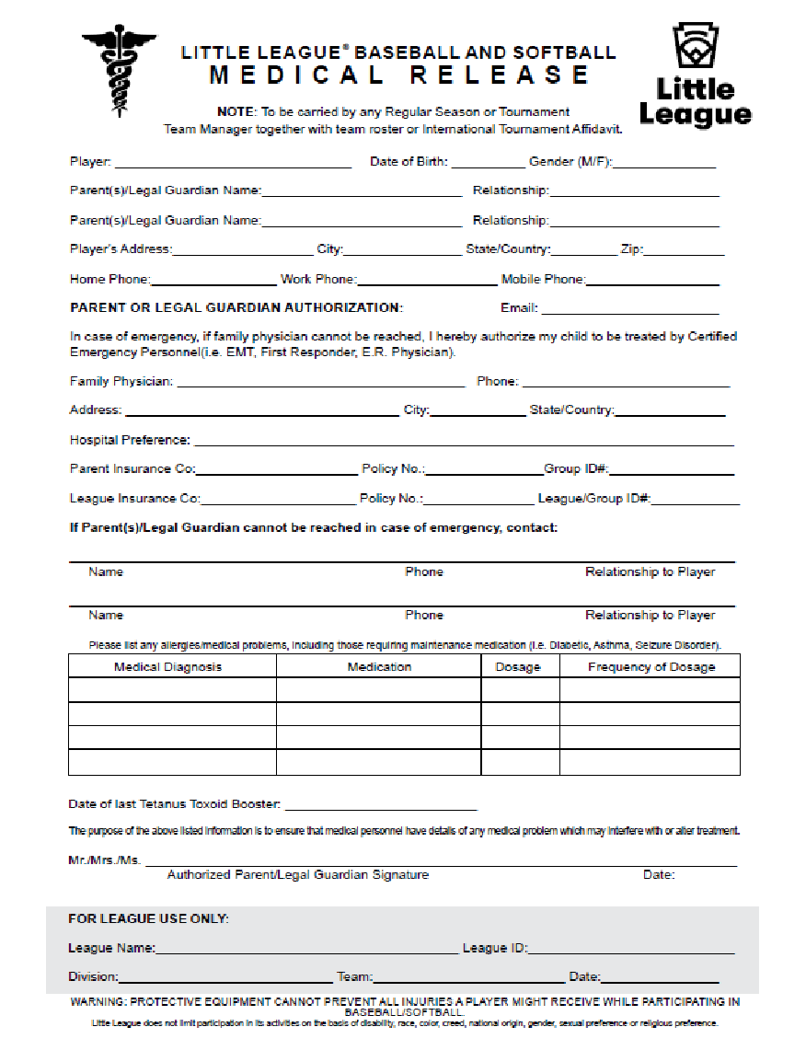

Incident/Injury Tracking Report Form
Download this form here: https://www.littleleague.org/downloads/incident-injury-tracking-form/
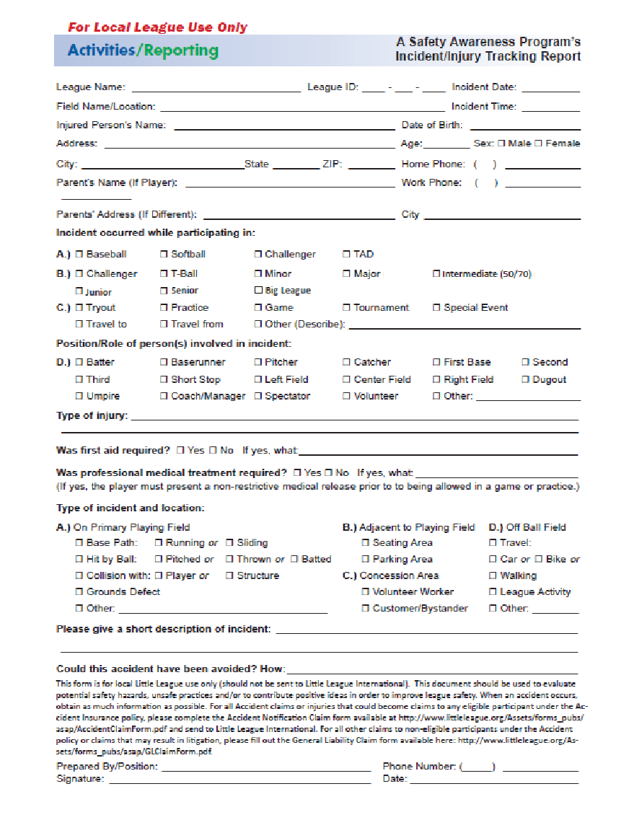

Little League Volunteer Application Form
